**Project 2: Classic or Grid Based Design**

* **Choose 1** of the following items to complete, your topic is a specific food or food product.
* Your submission should include an **HTML file, CSS File and any images**
* Your work should be focused on items learned in class – outside sources should be cited
* **Spend most of your time focused on HTML and CSS** and minimize time on curating content

**Classic**

**Create a single HTML page that uses some classic design principles (as shown in an example below)**

**This figure explains a page layout with floating elements.
The figure consists of three sections and an image with borders on either side of the figures. The first section, the topmost section in the figure, is a horizontal rectangle that reads “Pandaisia Chocolates”. The address of the company, “414 Tree Lane Essex, VT 05452”, is positioned at the bottom-left corner of this first section. A rectangular box labeled “Page body is horizontally centered within the browser window” is positioned on top of the first section at the center of the figure. An arrow originating from this box points to the first section of the figure.
A header with five menu options labeled “Home”, “Online Store”, “My account”, “Specials”, and “Contact Us” is positioned at the bottom of the first section. A rectangular box labeled “Horizontal list items are floated into separate columns” is positioned to the right side of the figure. An arrow originating from this box points to the header at the bottom of the first section.
The second section is a vertical rectangle that contains text, positioned to the left in the figure, describing Pandaisia Chocolates. An image of chocolates is positioned to the right of this text. A rectangular box labeled “Left and right sections are floated into separate columns” is positioned below the second rectangular box. An arrow originating from the third rectangular box splits and points to the text and the image in the second section of the figure.
The third section is a horizontal rectangle that contains four columns consisting of a list each. The four columns are: The Store, Products, Services, and Location and Hours. A rectangular box labeled “The contents of the page footer are floated into separate columns” is positioned below the third section and at the center of the figure. An arrow originating from this box splits and points to the four columns of list.
**

**For full credit, it should include:**

* **Full width banner image**
* **Navigation Menu with 3-6 items listed**
* **Multi-column, main content area that uses a combination of position, display and float**
* **Footer with 4 columns and links**
* **Overall style matching the theme, including various colors, text styles and images**
* **Please note – DO NOT USE HTML TABLES TO MIMIC THIS DESIGN**

**Grid**

**Create a single HTML page that uses grid design principles (as shown in an example below)**

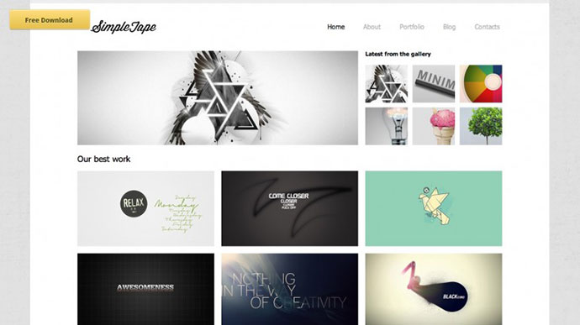

**For full credit, it should include:**

* **Navigation Menu with logo and 3-6 items listed**
* **Multi-column, main content area that uses a combination of position, display and float**
* **Varying image arrangements/sizes and row/column sizes/number (your grid should not solely contain identical elements)**
* **Overall style matching the theme, including various colors, text styles and images**
* **Footer of your choosing**

**Please note – DO NOT USE HTML TABLES TO MIMIC THIS DESIGN**